What is Cucumber?
Cucumber is the most popular test automation tool for Behaviour Driven Development (BDD). It is also open-source and managed by SmartBear. One of the key features of Cucumber is it allows one to write tests in plain English language with a specific format.
Gherkin syntax is used for Cucumber tests which is a plain English-like language for writing test cases. Cucumber also supports multiple languages, and it provides integration capability with many popular test automation frameworks.
How to Integrate Playwright with Cucumber
- Set Up the Project Structure: Initialize a Node.js project and install Playwright, Cucumber, and required dependencies.
- Create Feature Files: Write test scenarios in Gherkin syntax to describe application behavior in plain language.
- Implement Step Definitions: Map Gherkin steps to Playwright actions using JavaScript or TypeScript.
- Configure Playwright Hooks: Use hooks to manage browser setup, teardown, and shared test context.
- Run and Validate Tests: Execute Cucumber tests and ensure Playwright handles browser interactions reliably.
Step-by-Step Guide to Set up Playwright Cucumber
Step 1: Set up folders
Create an empty directory of your desired drive and name it (Example: PlaywrightCucumberDemo)
Step 2: Install Playwright
- Open the Above created folder by Clicking on File > Open Folder in Visual Studio Code
- Open the Terminal by Choosing the Terminal menu. Select New terminal
- Execute the below command
npm init playwright@latest
- Choose the language as Javascript when asked in the command line.
- Select the appropriate option in CLI as shown below.
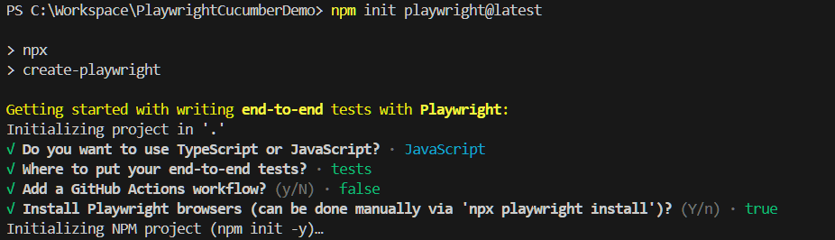
After executing the above command, Playwright will automatically install the required packages, browsers, and other components.
Step 3: Install Cucumber
Open the VS Code terminal and use the below command to install Cucumber.
npm i @cucumber/cucumber
Step 4: Configure Cucumber
You have installed all required dependencies for Playwright Cucumber, now you need to configure Cucumber.
- Create a cucumber.json file in the root of your Project folder. In this case, it is PlaywrightCucumberDemo.
- Use the below example code to create a cucumber.json
{

"default": {
"paths": [
"tests/features/"
],

"require": [
"tests/steps/*.js"
],

"formatOptions": {
"snippetInterface": "async-await"
},

"format": [
[
"html",
"cucumber-report.html"
],
"summary",
"progress-bar",
"json:./cucumber-report.json"
]
}
}

The cucumber.json contains the feature file path, step definition file path, reporting options, and output directory. You are free to customize this file as per your requirements.

Step 4: Write a Cucumber tests
Cucumber tests contain two different files: the feature file and the step definition file. The feature file contains the scenarios in Gherkin format that are Given, When, and then format, and the Step Definition file contains the actual code or implementation of test cases.

Create two folders, namely features and steps, under the tests folder
Note:
- tests folder is already created by Playwright while installing
- If the test folder contains example tests, delete them to avoid any confusion.

Consider two scenarios.
- Scenario 1: Navigate to Browserstack Homepage and Click on Product. Verify if there is a Web Testing option available.
- Scenario 2: Navigate to Browserstack Homepage and Click on the Pricing section. Verify if all the products are listed in the Left Navigation.

Write the cucumber feature file for the above scenario. Create a file with the name homepage.feature inside the features folder and write the scenarios as mentioned below

Feature: Homepage Functionality

Scenario: Verify Product Web Testing
Given User navigates to the Browserstack Homepage
When User clicks on Product Menu
Then It should show Web Testing Product

Scenario: Verify Pricing Product Lists
Given User Navigates to Browserstack Homepage
When User clicks on Pricing Menu
Then It should Display correct Product lists in left Nav

As you created feature files, now you need to implement them in a step definition file.
Create a file with the name homepage.step.js and write the implementation below.

const { Given, When, Then, Before, After, setDefaultTimeout } = require("@cucumber/cucumber");

const { chromium, expect } = require("@playwright/test");
const { Page } = require("playwright");
setDefaultTimeout(60 * 1000);

let page, browser;

Before(async function () {
browser = await chromium.launch({ headless: false });
const context = await browser.newContext();
page = await context.newPage();
});

Given("User navigates to the Browserstack Homepage", async () => {
await page.goto("https://www.browserstack.com/");
});

When('User clicks on Product Menu', async function () {
await page.locator('button[aria-label="Products"]').waitFor();
await page.locator('button[aria-label="Products"]').click();
});

Then('It should show Web Testing Product', async function () {
await page.locator('div[aria-label="Products"] button[title="Web Testing"]').waitFor();
expect(await page.locator('div[aria-label="Products"] button[title="Web Testing"] span').isVisible()).toBeTruthy();
});

Given('User Navigates to Browserstack Homepage', async function () {
await page.goto("https://www.browserstack.com/");
});

When('User clicks on Pricing Menu', async function () {
await page.locator('a[title="Pricing"]').click();
});

Then('It should Display correct Product lists in left Nav', async function () {
var leftNavProducts = await page.locator('div[id="sidenav__list"]').textContent();
var productArray = await leftNavProducts.split("\n").map((item) => { return item.trim(); });
expect(productArray).toEqual(expect.arrayContaining(['Live', 'App Live']));
});

After(async function () {
await browser.close();
})

In the above code, we have implemented two scenarios. The first set of Given, When, and Then belongs to the first scenario, which is “Scenario: Verify Product Web Testing“, and the Second set belongs to the second scenario, “Verify Pricing Product Lists“.
To avoid writing a browser creation and setting up a page each time, we are putting it as a common code inside the Before() function, which executes before each test, and the After() function helps to close the browser after execution of each test.
After completion of the above steps, the Project structure looks like below.
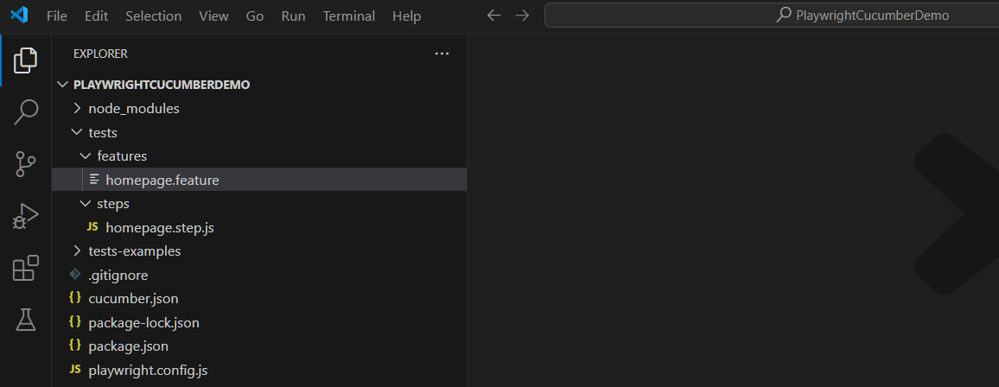

Executing Cucumber Playwright Tests
You have configured the Playwright Cucumber framework, and test cases are written in respective files. To execute Cucumber Playwright tests, just enter the below command
npx cucumber-js test
Once you enter the above command, it invokes the cucumber test runner, and progress will be shown in the console. Once execution is complete, the output will be shown in the console.
Test Progress in Console:
Output:
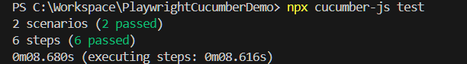
Reporters in Cucumber Playwright Framework
Cucumber Playwright comes with a default HTML reporter. The configuration is made in the cucumber.json file in the format section (Ref: “format”: [ [ “html”, “cucumber-report.html]]). Once execution is complete, the report will be generated in the root directory with the name cucumber-report.html
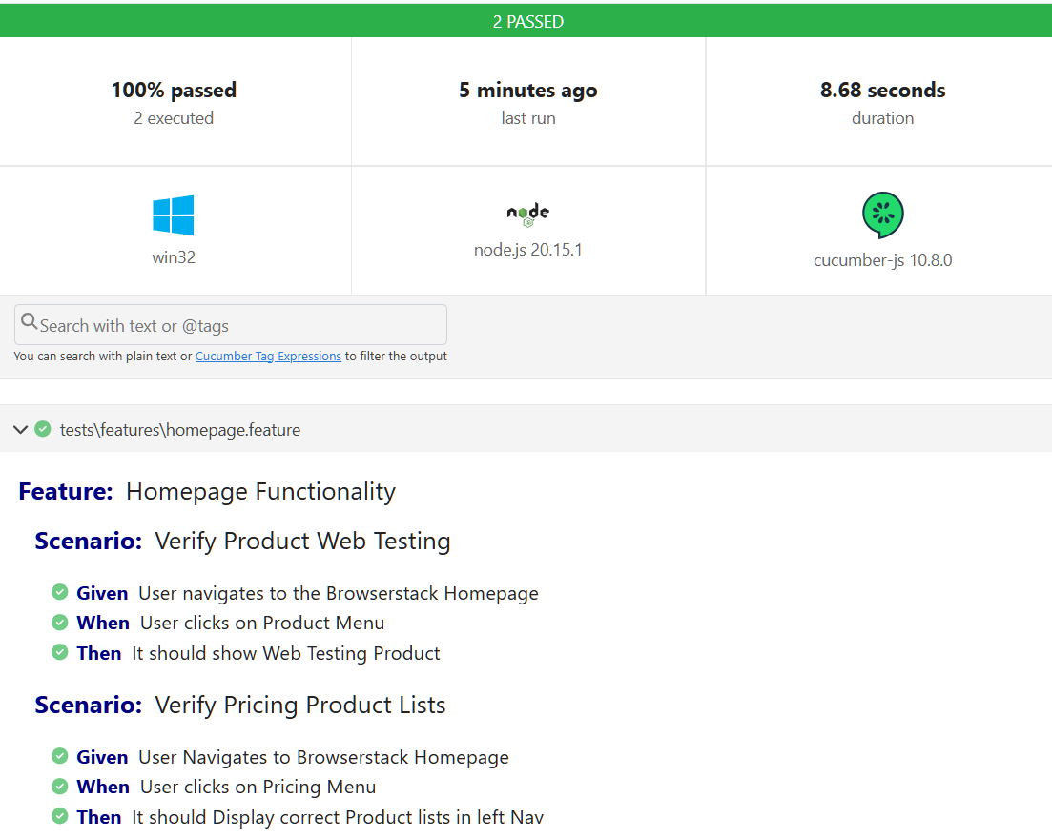

Note:
  - Add a test script to your package.json file to easily run your tests:
"scripts": {
"cucumber": "cucumber-js test"
}
Execute the tests from your terminal:
npm run cucumber
  - Installing Cucumber extension in the VS Code will make things easier to identify the file created and the keywords getting highlighted with color

